**User manual**

*KoersWest*



**Rik Langeveld** *500730015*

**Gijs Sickenga** *500727522*

**Hussein Swadi** *500714904*

# Table of contents

Table of contents 2

Introduction 2

Account 3

Register/New Account 3

Logging in 6

Offering a service 7

Asking for a service 9

Profile 11

Change information 12

Offered services 13

Asked for services 15

Matching 17

# Introduction

BOOT has giving us a chance to make a website for them. In this document we will explain every function of the website and the common errors that occur when information isn’t filled in in the right way.

The chapters we will be going thru will be: “Account, offering a service, asking for a service, profile and matching”. We will explain in Account how to register on the website and how to log in and what common errors will occur when you forgot to fill in certain fields. In offering a service and asking a service we will describe how to offer a service to users. We will describe step by step how to offer your service you’re good at or a service you need help with. In profile we will describe how to change your information and how to see your offered and asked for services. When we will come to matching we will describe how the matching works and what the differences are between some matches, how to send your information to someone when they need your help or how to receive information from other users.

# 

# Account

## Register/New Account

To create an account certain information is needed. Such as, an e-mail address and your personal information. On the website you have the choice between log in and register. Click on the register button to create an account. On the registration page you can go back to the home page by clicking on the big grey square with the back arrow ‘Klik om terug te gaan’.

Under the heading ‘Inloggegevens”, enter your email in the email field and your password in the ‘wachtwoord’ field. The password needs to be entered 2 times as an additional check.

Under the heading ‘Persoonsgegevens’ please fill in your personal information.

Under the heading ‘Naam’, enter your first name.

Under the heading ‘Tussenvoegsel’, enter your infix if it applies.

Under the heading ‘Achternaam’, enter your surname.

Under the heading ‘Tel. Nummer’, enter your mobile/home phone number.

Under the heading ‘Straat’, enter your address.

Under the heading ‘Postcode’, enter your zip code.

Under the heading ‘Woonplaats’, enter your residence.

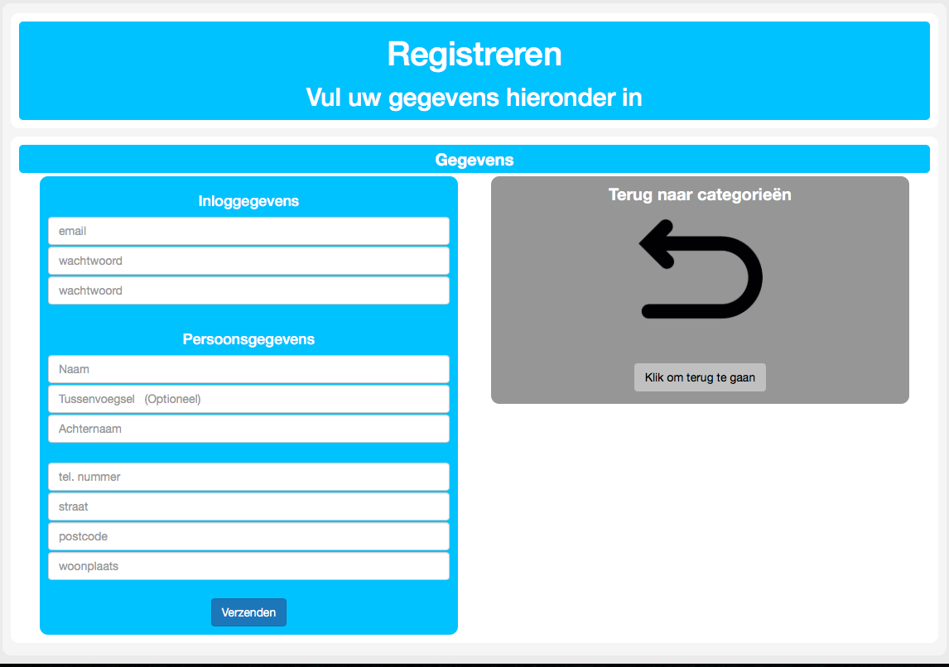

Once all the fields are completed, press the ‘Verzend’ button. If fields are left open, there will be a large orange examination sign saying: Please note that you forgot to fill in fields.

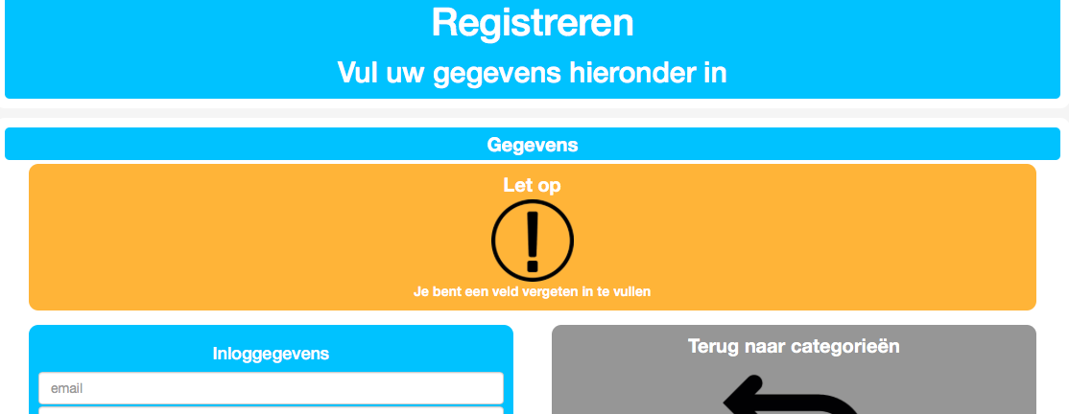

When you press the send button it will take you to a new page where you will see various categories. Select the category that you’re good at by pressing the button "Kiezen". When you select a category it turns orange, by clicking the button ‘Bevestigen’ you will confirm your choice.

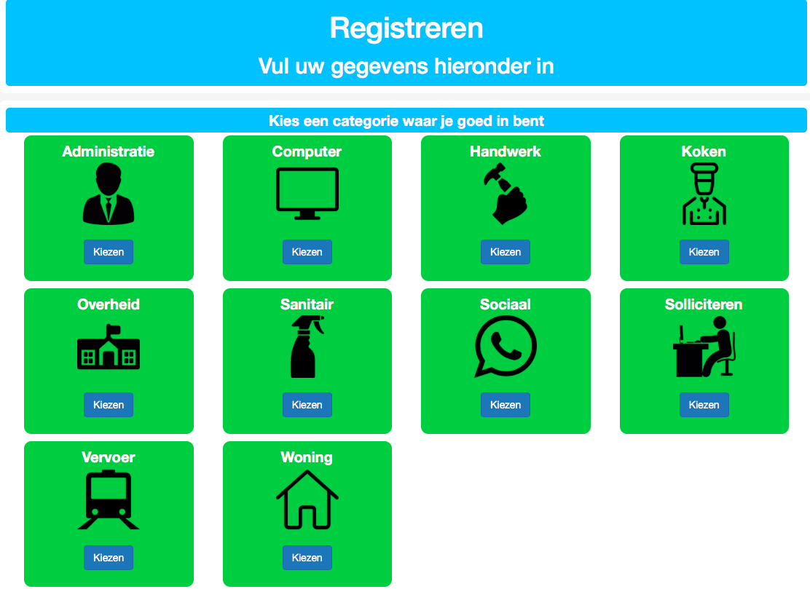

After selecting the category you’re good at you will automatically be redirected to another page where you can request help for the service you need assistance with.

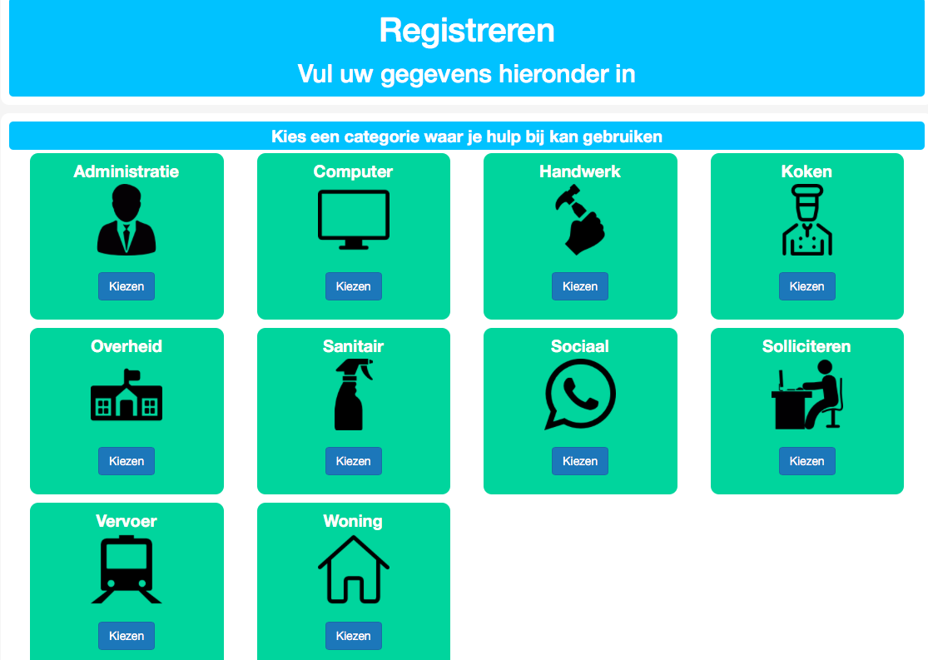

When you have finished selecting and confirming a category it takes you to another screen where it notifies you that the registration is successful. You will see a button with the sign ‘Inloggen’ that takes you back to the home page where you can log in and use the information you just filled in.

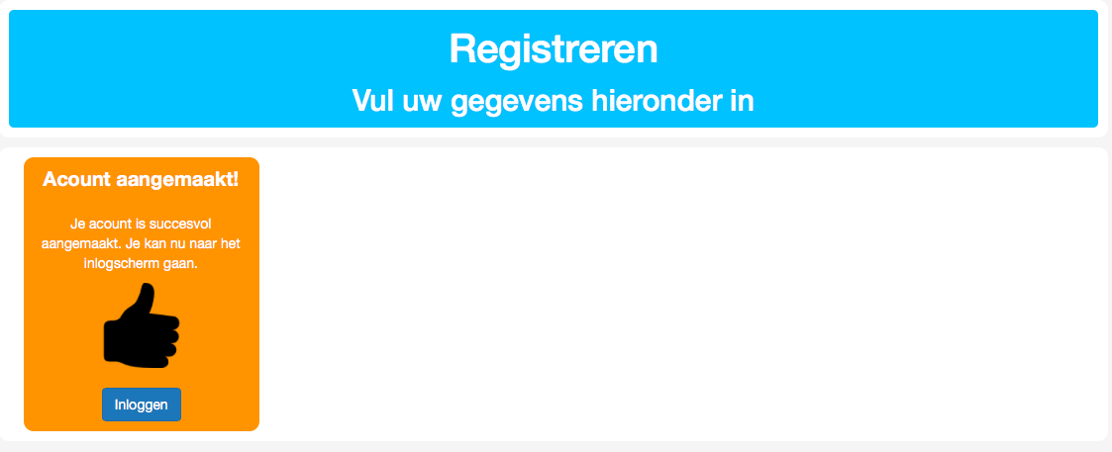

## Logging in

In order to log in you must be in possession of an account. On the website there are two options, log in and register. When you log in use the left button "Ga naar inlogscherm' button, enter your email and password in the appropriate fields. After filling in details, press the green login button.

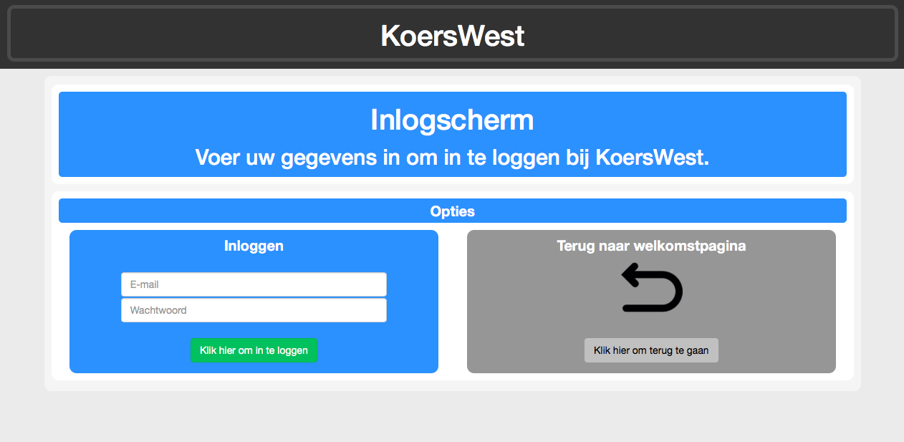

After logging in you will be shown on the main menu where pages like profile, offering service, asking for service, matching and logout are.

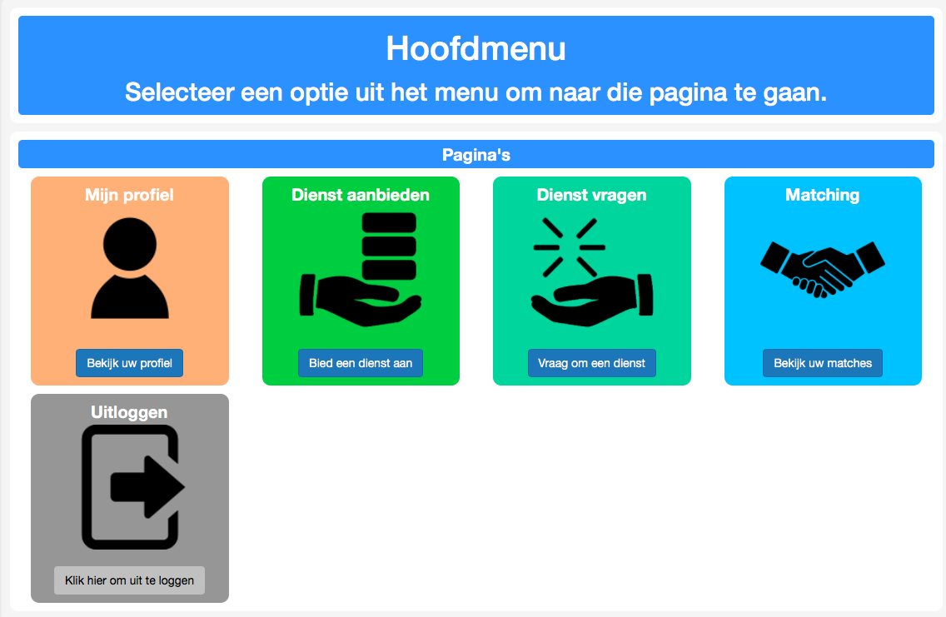

# Offering a service

To offer a service you have to be in possession of an account. After logging in you can reach the main menu. On the page the heading ‘’offering a service’’ is shown next to profile and asking for a service. After pressing "offering a service" you will go to a new screen where a list with categories are displayed.

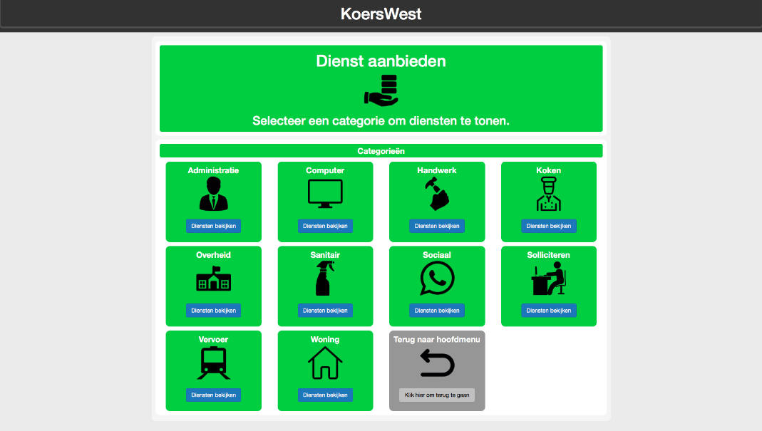

After pressing the category in which you are good at you will enter a screen with services associated with that category. To offer a service, press the service that you are good at. The pictures will show you what the service consists of.

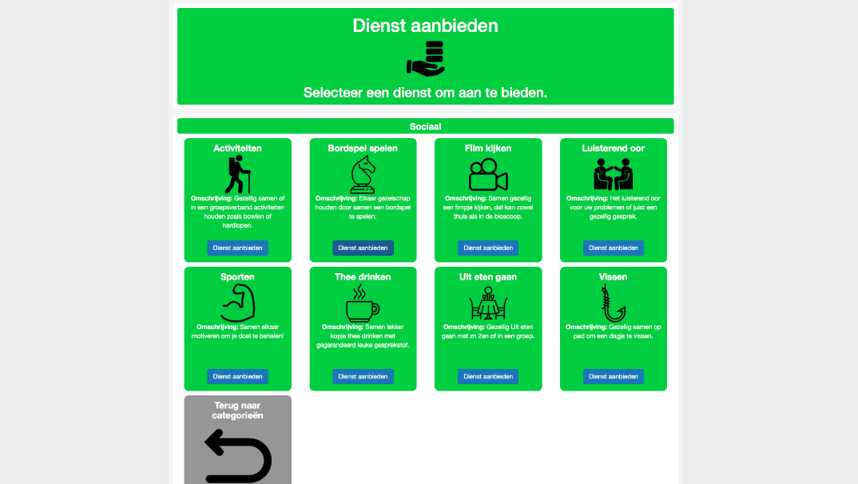

After pressing the blue button, the colour of the image turns orange and shows that you are now offering the service. If you are already offering a service, the service will have a darker colour with a text underneath stating that you are already offering the service. You can do this with multiple services of different categories, to increase the chance of being matched.

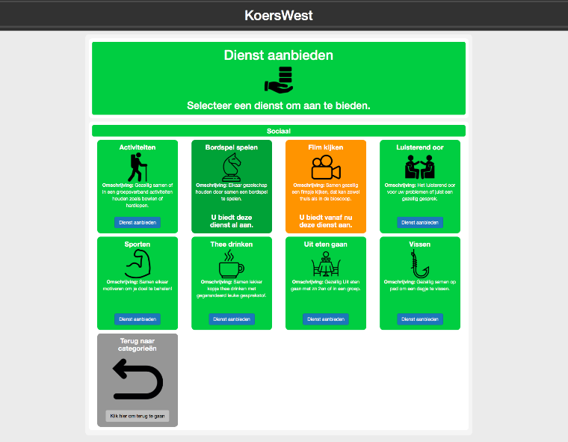

# Asking for a service

To ask for a service you have to be in possession of an account. After logging in you can reach the main menu. On the page the heading ‘Asking for a service’’ is shown next to matching and offering a service. After pressing "Asking for a service" you will go to a new screen where a list with categories are displayed.

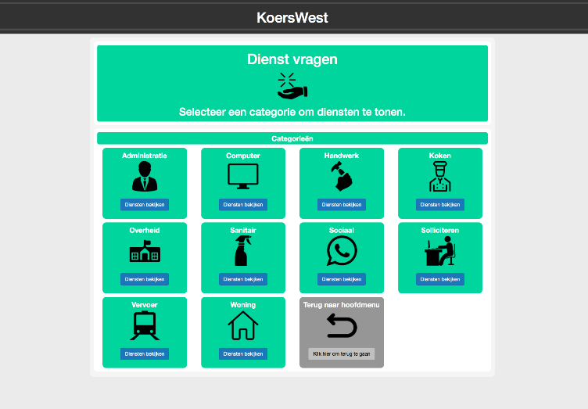

After pressing the category in which you are good at you will enter a screen with services associated with that category. To ask for a service, press the service that you need help with. The pictures will show you what the service consists of.

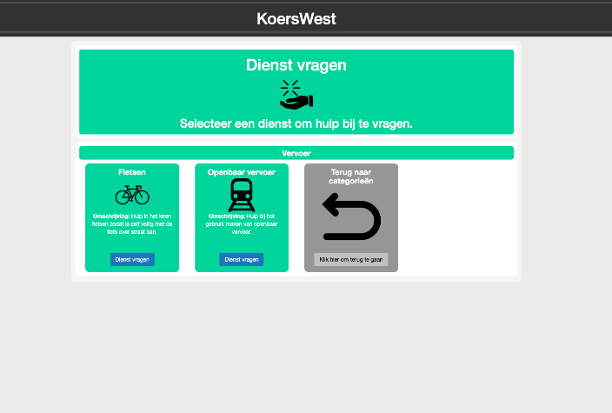

After pressing the blue button, the colour of the image turns orange and shows that you are now asking for the service. If you are already asking for a service, the service will have a darker colour with a text underneath stating that you are already asking the service. You can do this with multiple services of different categories, to increase the chance of being matched.

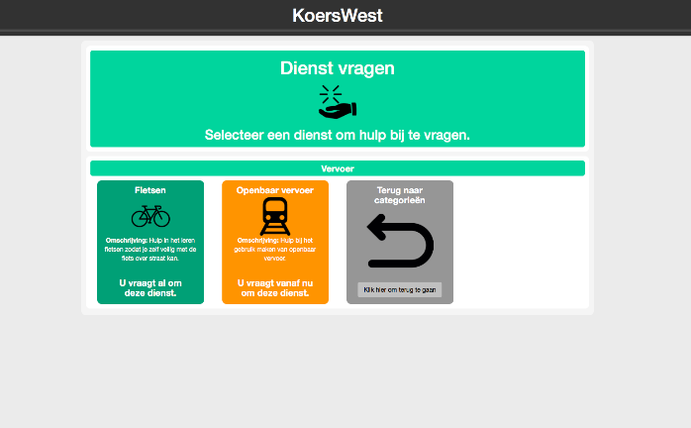

# Profile

## Change information

In order to change your information, you first have to log in. After logging in you will reach the main menu. Here the first thing that is being displayed is Profile.

After pressing the heading ‘’profile’’ it takes you to a screen where the heading profile becomes separated in to personal information, services offered, asked services, and return to main menu button.

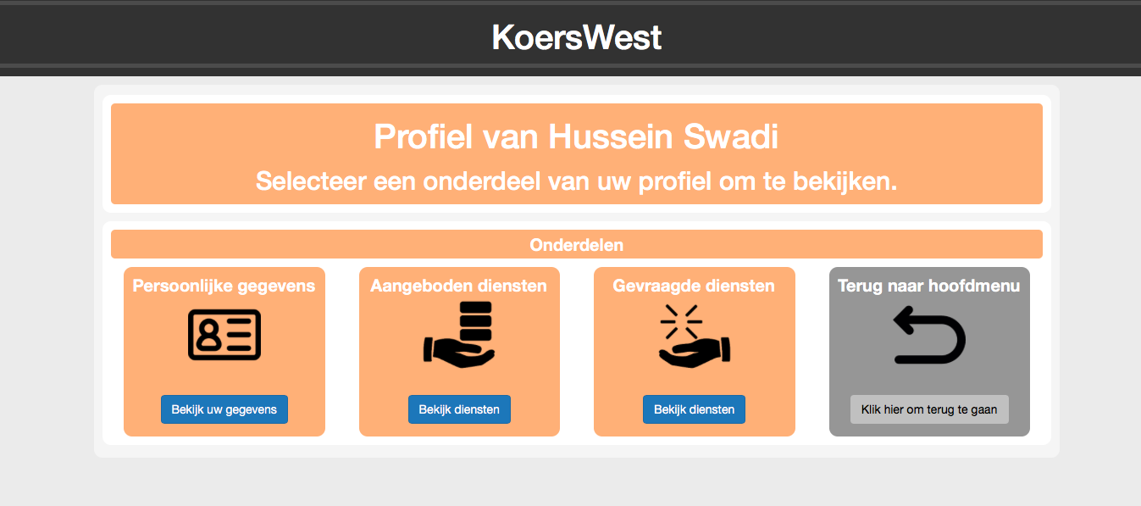

When you press personal information you will be shown your information. This screen is divided into sections including personal details, address information and again a back button.

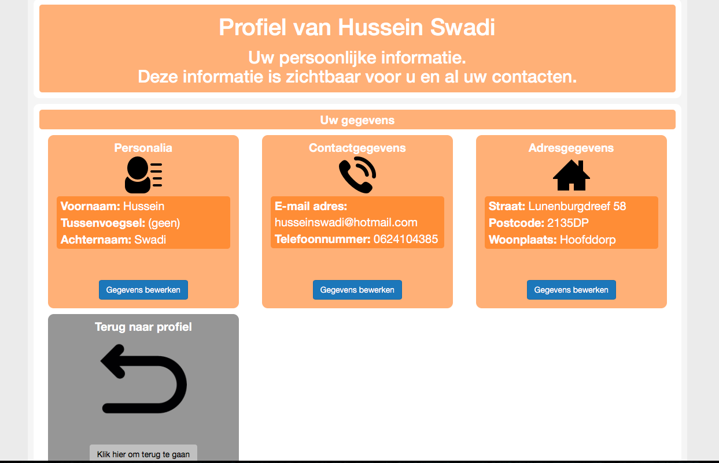

The data that’s being displayed is the data which has been noted in the registering process. By clicking on the blue button to update data, you will have the opportunity to change your information. The fields with a star behind them must be filled in. If your data is complete, you can either complete the operation or cancel. This is shown with a green and red button.

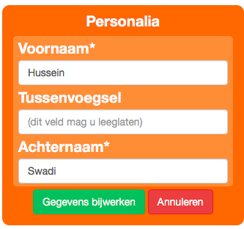

When you haven’t filled in all the data the system returns an error message with an orange exclamation mark saying data is missing and beneath the error message is typified.

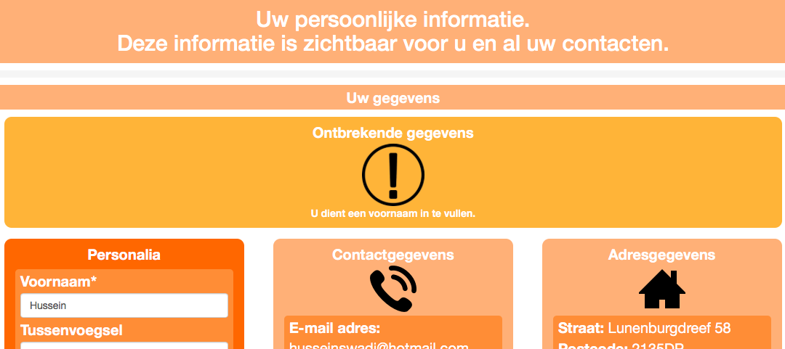

## Offered services

To see what services you are offering you must go to the profile page on the main menu. Once you’ve clicked on “Profile” it will show your personal information, offered services and asked services. On the profile page the offered services will be shown next to your personal information and asked for services. After pressing the blue button “View services” the system will show all the categories that are available.

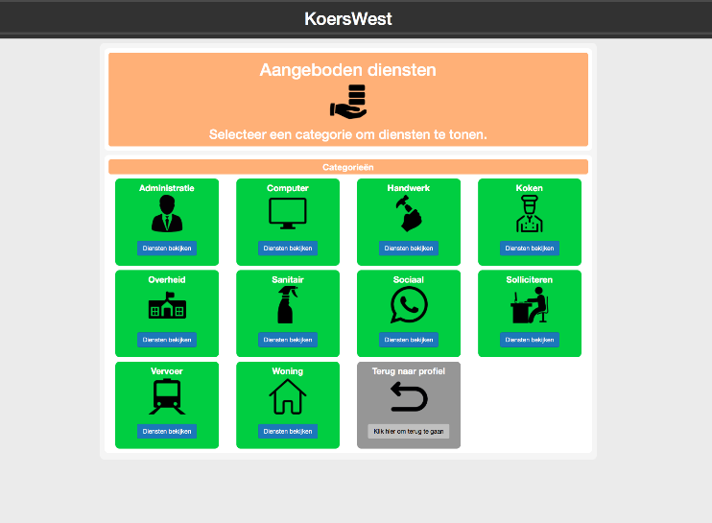

After pressing the category, the system will show you all the services you are offering of that category with the text beneath “you are offering this service”.

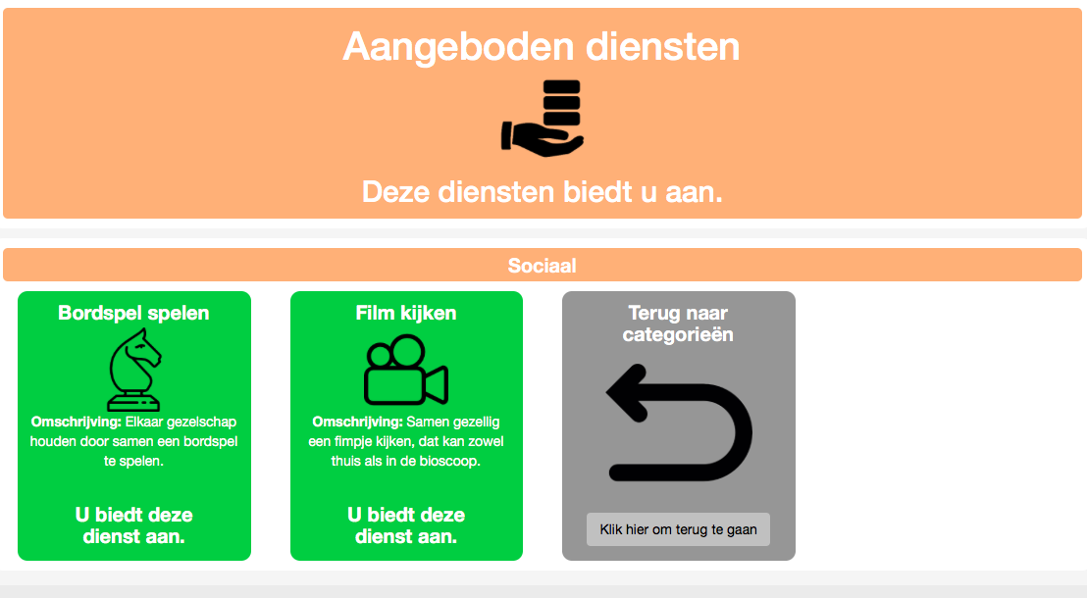

When you are not offering any services of that category the system will display an exclamation mark confirming the previous. Once you’re finished you can go back to the categories by clicking on the big grey square with the back arrow.

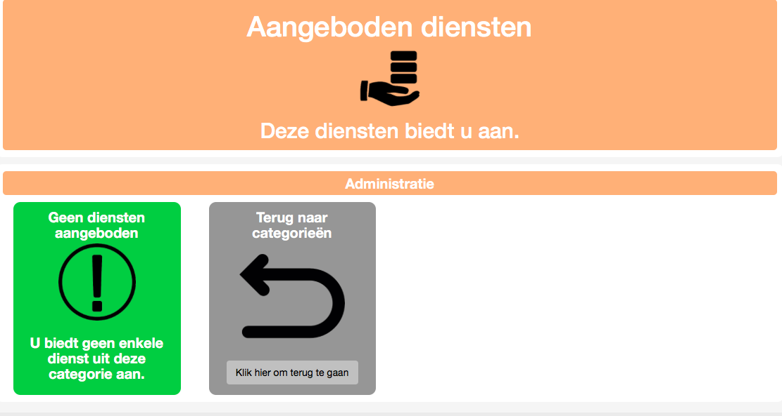

## Asked for services

To see what services you asked for you must go to the profile page on the main menu. Once you’ve clicked on “Profile” it will show your personal information, offered services and asked services. On the profile page the asked for services will be shown next to the big grey square with the back arrow and offered services. After pressing the blue button “View services” the system will show all the categories that are available.

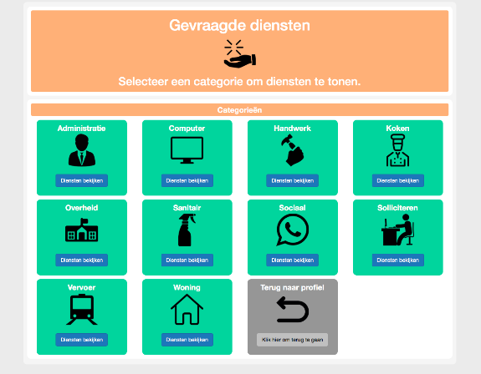

After pressing the category, the system will show you all the services you are asking for that category with the text beneath “you are asking for this service”.

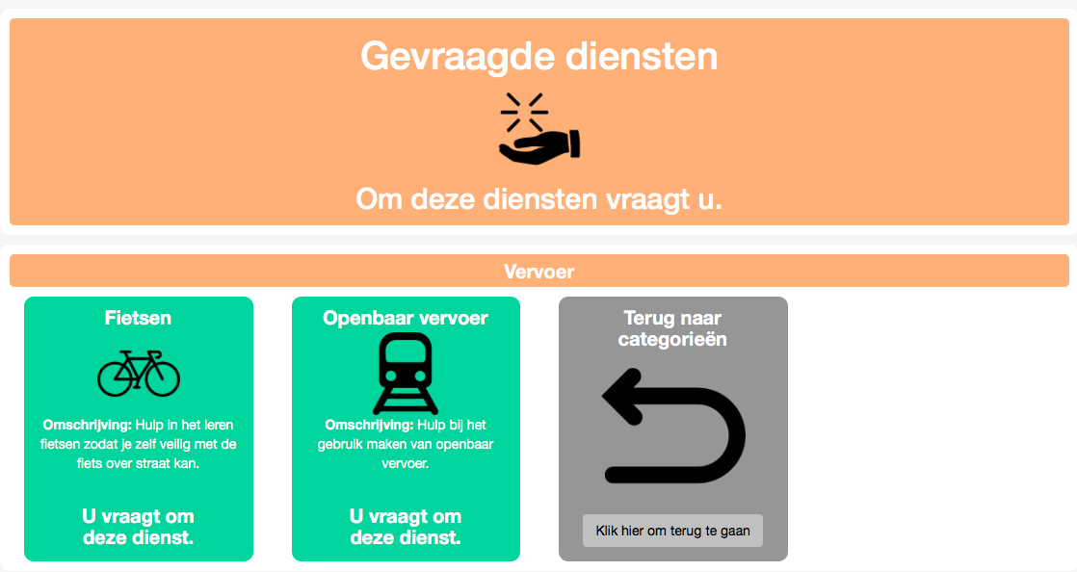

When you are not asking any services of that category the system will display you an exclamation mark confirming the previous.

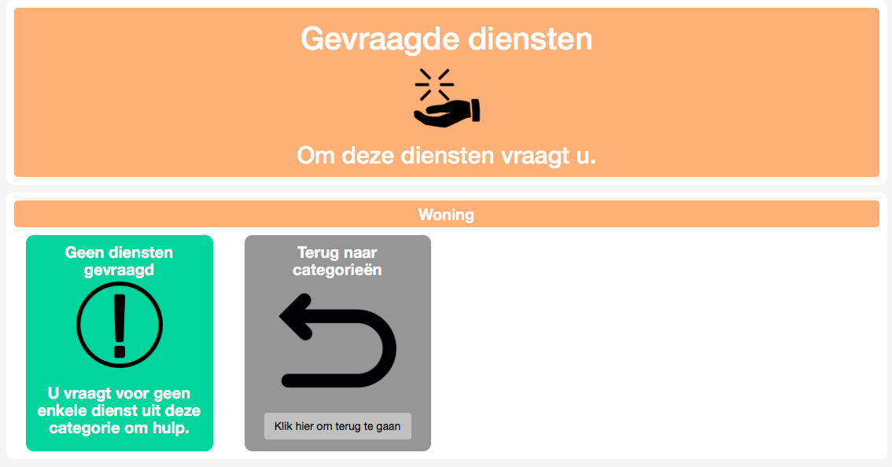

Once you’re finished you can go back to the categories by clicking on the big grey square with the back arrow.

# Matching

In order to view your matches, you must both offer a service and also ask for a service. Once you’re logged in you’ll get redirected to the home page. On the home page the heading “Matching” is shown. After pressing “Bekijk uw matches” you’ll get to the match screen.

There are 4 kinds of matches:

* Found matches on what you are offering and requesting
* Found matches with opposite talents
* People who accepted your request
* People with opposite talents who accepted your request

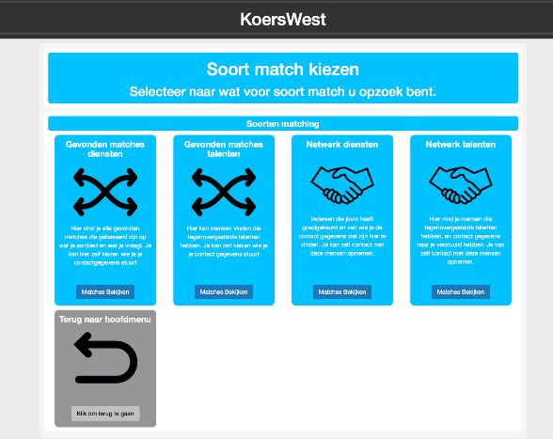

When you click on ‘’found matches’’ you will be linked to the page where all matches are found based on your offer and request. If someone is matched to you, the match will be shown next to the big grey square. You will see both the name of the person and which offer or request you’re being matched with. Beneath it will show you 2 buttons, a green and a red one. Once you’ve clicked the green button you will send your information to the other user to get contact.

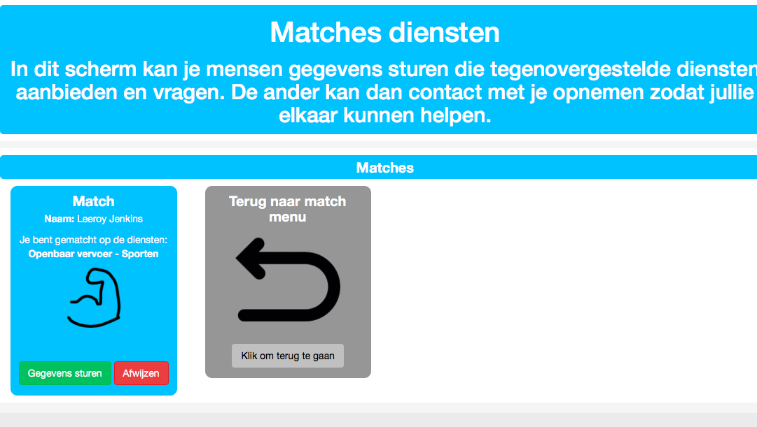

Once you’ve clicked on the red button you will reject the offer. The match will not be displayed again at the match screen.

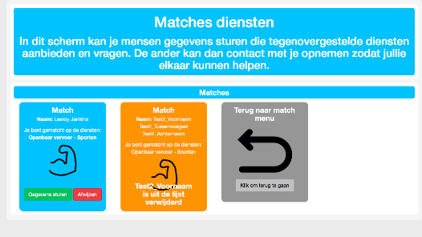

Instead it will say “Geen match” meaning no match.

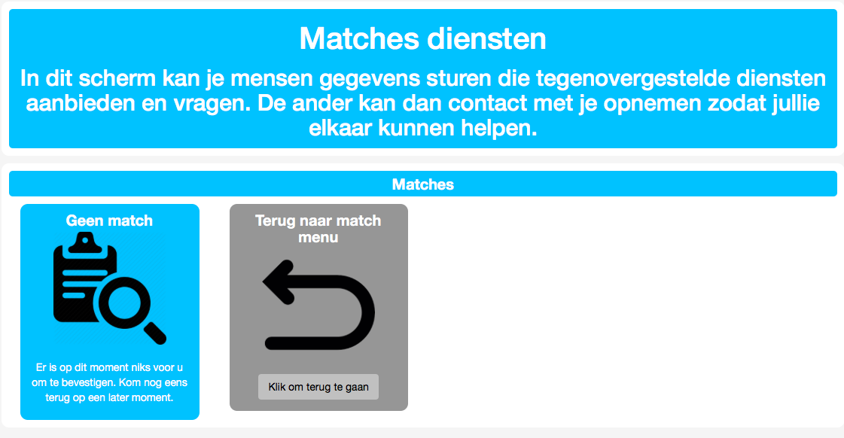

When you click on the ‘’found matches with opposite talents’’ button you will be linked to the page where all matches are found based on opposite talents. If someone is matched to you, the match will be shown next to the big grey square. You will see both the name of the person and which talent you’re being matched with. Beneath it will show you 2 buttons, a green and a red one. Once you’ve clicked the green button you will send your information to the other user to get contact. Once you’ve clicked on the red button you will reject the talent. The match will not be displayed again at the match screen. Instead it will say “Geen match” meaning no match.

When you click on ‘’people who accepted your request’’ you will be linked to the page where all matches are found who accepted your offer and request. When someone accepted your offer and request, his or her contact information consisting of name, e-mail and telephone number will be shown. Now you can contact the other person.

When you click on ‘’people who accepted your request’’ with opposite talents you will be linked to the page where all matches are found who accepted your talent. When someone accepted your talent, his or her contact information consisting of name, e-mail and telephone number will be shown. Now you can contact the other person.